**Final project DBMS – 1**

**Made by: Arina Ussubaliyeva**

**Meruyert Kerimbayeva**

**Sabina Rakhmetova**

**Introduction**

This project about the university database system.Our system basically consists based on these beliefs:We have students that have their own accounts in the university portal and the same works for teacher and staff members.

Using all the information provided by the database, you can easily find out in which faculty, course and subjects the student studies and for teacher(lecturer and practice) which subjects they teach and in which faculty they work.

In addition, we have Dorm tables from where we can find out which students live there, also we have catering, which has attributes with description about dinner. Parking tables from where we can find out which staff and students have permission for parking.

1. **ER Diagram**

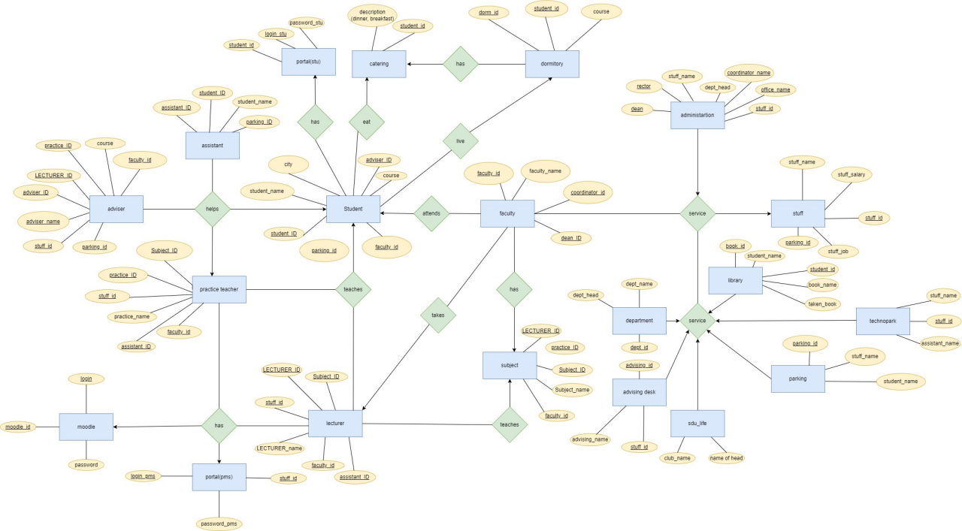

1. **Functional Dependencies**

**1 table** Student

Student_ID, Student_name, City, Course, Adviser_ID, Faculty_ID, Parking_ID

**2 table** Adviser

Adviser_ID, Adviser_name, Course, Faculty_ID, Lecturer_ID, Practice_ID, Stuff_ID, Parking_ID

**3 table** Practice_Teacher

Practice_ID, Practice_Name, Subject_ID, Assistant_ID, Faculty_ID, Stuff_ID

**4 table** Lecturer

Lecturer_ID, Lecturer_Name, Subject_ID, Assistant_ID, Faculty_ID, Stuff_ID

**5 table** Subject

Subject_ID, Subject_name, Lecturer_ID, Practice_ID, Faculty_ID

**6 table** Faculty

Faculty_ID, Faculty_Name, Coordinator_ID, Dean_ID

**7 table** Assistant

Assistant_ID, Student_ID, Student_name, Parking_ID

**8 table** Administration

Stuff_ID, Stuff_name, Coordinator_name, Office_name, Dept_head, Rector, Dean

**9 table** Department

Dept_ID, Dept_name, Dept_head

**10 table** Library

Book_ID, Book_name, Taken_Book, Student_ID, Student_name

**11 table** Stuff

Stuff_ID, Stuff_name, Stuff_salary, Stuff_job, Parking_ID

**12 table** Technopark

Stuff_ID, Stuff_name, Assistant_Name

**13 table** SDU_life

Club_name, Club_head

**14 table** Advising_Desk

Advising_ID, Advising_name, Stuff_ID

**15 table** Parking

Parking_ID, Student_name, Stuff_Name

**16 table** Dormitory

Dorm_ID, Student_ID, Course

**17 table** Catering

Student_ID, Description

**18 table** Portal(stu)

Student_ID, Login_stu, Password_stu

**19 table** Portal(pms)

Stuff_ID, Login_pms, Password_pms

**20 table** Moodle

Moodle_ID, Login, Password

1. **Normalization**

**1NF**

All tables in 1NF, because all attributes of these relations are simple.

**2NF**

All table are in 2NF, because they are in 1NF and have primary keys : Student_ID, Adviser_ID, Practice_ID, Lecturer_ID, Stuff_ID, Parking_ID, Moodle_ID, Subject_ID, Faculty_ID, Dept_ID, Advising_ID, Book_ID, Dorm_ID, Assistant_ID

**3NF**

Tables Student, Catering, Adviser, Assistant, Practice_teacher, Lecturer, Moodle, Portal, Portal(pms),

Subject, Faculty, Department, Advising_desk, Library, Stuff, Parking

are in 3NF, because they are reduced to 2NF. and all non-key attributes are mutually independent and completely dependent on the key.

**BCNF**

Some tables are in BCNF

1. **Queries**

1) SELECT Student_ID, Description

FROM Catering;

2) SELECT Student_name, city

FROM Student

WHERE city= ‘Kuala Lumpur’ OR ‘Oslo’;

3) INSERT into Portal_pms

VALUES (9100, ‘coco@jimbo.com’, ‘fFfFfF’);

4) UPDATE Practice_teacher

SET Practice_name= ‘Mutaliev Nauryzbay’

WHERE stuff_id = 1281;

5) Alter table Student

ADD Student_Gender VARCHAR(6);

6) DELETE

FROM library

WHERE Student_ID = 880;

7) SELECT head_name , club_name

FROM sdu_life

ORDER BY club_name asc;

8) SELECT stuff.stuff_id, Stuff.salary, Technopark.stuff_name,

Technopark.Assistant_name

FROM Technopark

INNER JOIN

Stuff ON

Technopark.Stuff_ID = Stuff.Stuff_ID;

9) SELECT MIN(salary)

FROM Stuff

WHERE parking_id IS NOT NULL;

10) SELECT stuff_ID

FROM adviser

INTERSECT

SELECT stuff_ID

FROM administration

11) SELECT SUM(salary)

FROM Stuff

WHERE Stuff_name= ‘A%’;

12) SELECT AVG(course)

FROM Student

WHERE Student_ID > 100;

13) CREATE TRIGGER New_Student1

AFTER UPDATE ON dormitory

WHEN new.course = 2

BEGIN

INSERT INTO dormitory (

student_id,

dorm_id,

course

)

VALUES

(111,

222,

1

) ;

END

14) UPDATE dormitory

SET course = 2

WHERE Student_id = 638

15) SELECT practice_teacher.practice_name,

practice_teacher.subject_ID, lecturer.lecturer_name, lecturer.subject_ID

FROM practice_teacher

LEFT JOIN

lecturer ON

lecturer.subject_id = practice_teacher.subject_id;

16) SELECT Practice_name

FROM Practice_teacher

UNION

SELECT Lecturer_name

FROM Lecturer

17) BEGIN TRANSACTION;

UPDATE stuff

SET salary=salary + 10000

WHERE stuff_id= 2051;

INSERT INTO department (dept_ID, dept_head, dept_name)

VALUES(7, 'Dama Lama', 'social');

COMMIT;

18) SELECT Student_id FROM portal_stu

Except

SELECT Stuff_id FROM portal_pms

19) UPDATE student

SET parking_id = NULL

WHERE course = 1

SELECT student_id

FROM student

WHERE parking_id IS NULL;

20) Group by,

SELECT lecturer_id, lecturer_name, faculty_id, subject_id

FROM Lecturer

WHERE faculty_id=004

GROUP BY Lecturer_id

ORDER by subject_id